Software Requirements Specification

for

Here

**Final Version**

**Prepared by:** Camilo B., Joseph I., Patrick B., Richard S., Sarah Perlotto

**August 6, 2017**

**Revision History**

|  |  |  |  |
| --- | --- | --- | --- |
| **Name** | **Date** | **Reason For Changes** | **Version** |
| Camilo, Joseph, Patrick, Richard, and Sarah | 5/21/2017 | Initial publication | 1.0 |
| Camilo, Joseph, Patrick, Richard, and Sarah | 5/28/2017 | Revise use cases for consistency with class diagram/planning elaboration | 2.0 |
| Camilo, Joseph, Patrick, Richard, and Sarah | 6/11/2017 | Refining use cases | 3.0 |
| Camilo, Joseph, Patrick, Richard, and Sarah | 7/2/2017 | Refining use cases | 3.1 |
| Camilo, Joseph, Patrick, Richard, and Sarah | 8/6/2017 | Final draft based on final implementation | 4.0 |

**Contents**

1. Introduction 4

1.1 Purpose 4

1.2 Scope 4

1.3 Definitions, Acronyms, and Abbreviations 4

1.4 Overview 5

1.5 References and Resources 5

2. Overall Description 5

2.1 Product Perspective 5

2.2 Product Functions 6

2.3 User Characteristics 6

2.4 Constraints 6

2.5 Assumptions and Dependencies 7

3. External Interface Requirements 7

3.1 User Interfaces 7

3.2 Hardware Interfaces 7

3.3 Software Interfaces 7

3.4 Communications Interfaces 7

4. Domain Model 8

5. System Features (Use Cases) 8

6. Other Nonfunctional Requirements 18

6.1 Performance Requirements 18

6.2 Safety Requirements 19

6.3 Security Requirements 19

6.4 Software Quality Attributes 19

7. Other Requirements 19

# Introduction

## Purpose

The purpose of this system requirements specification (SRS) is to document the functional and nonfunctional requirements that the Here application fulfills.

## Scope

Here is an application for Android smartphones that supports interest- and location-based notification driven by users’ existing social media profiles. Additional user-to-user messaging capability is also provided within the application to allow users with common interests to connect. Here provides a platform for an unlimited number of users. It is currently only available in the English language and best supports locations within the United States of America.

## Definitions, Acronyms, and Abbreviations

|  |  |
| --- | --- |
| **Term** | **Definition** |
| Android | Mobile-oriented cross-device operating system commonly used for smartphones |
| API | Application programming interface - used to communicate between separate systems |
| Application server | In these requirements, the application server refers to the hosting and data storage for Here |
| Authentication | The process of gaining access to a private system through a log in procedure |
| Cell / data network | Communication networks with connectivity provided via mobile cellular networks (e.g. 4G LTE) and internet service (e.g. WiFi) |
| Device storage | A device’s hard drive |
| Geofence | A geographic boundary that is tracked and may provide a response when the bounded zone is entered or exited |
| GPS | Global positioning system - used to identify a specific location (e.g. smartphone user) |
| Keyboard / special characters | Method used to input text data into a device – may include multiple languages and character types (e.g. emoji) |
| Open | An application is considered to be open if it is running and currently displayed |
| Proximity radius | See geofence |
| Running | An application is considered to be running if it has been opened and has not been closed – it may or may not be displayed |
| Smartphone | A mobile device with phone, internet, and application use capabilities |
| System | In these requirements, the system refers to the Here application as it is presented to the user and as it operates on the backend |
| Token | A software artifact used to validate a process such as authentication |

## Overview

The SRS will describe the how Here will relate to its environment, context, and users starting from a high-level system perspective and honing in on details through use cases.

## References and Resources

* Android developer resources: <https://developer.android.com/index.html>
* GPS.gov
* Amazon Web Services: <https://aws.amazon.com/>
* MongoDB: <https://www.mongodb.com/>
* nodeJS: <https://nodejs.org/en/>
* Firebase: <https://firebase.google.com/>
* Facebook Graph API: <https://developers.facebook.com/docs/graph-api>
* Google Places API: <https://developers.google.com/places/>
* Picasso: <http://square.github.io/picasso/>
* TagView: <https://github.com/Cutta/TagView>
* Robolectric: <http://robolectric.org/>
* PowerMock: <https://github.com/powermock/powermock>
* Mockito: <http://site.mockito.org/>

# Overall Description

## Product Perspective

The Here application will use:

* Smartphone user interface
* Smartphone hardware including device storage
* GPS location services
* Web server database
* Third-party platforms and APIs (see references and resources)

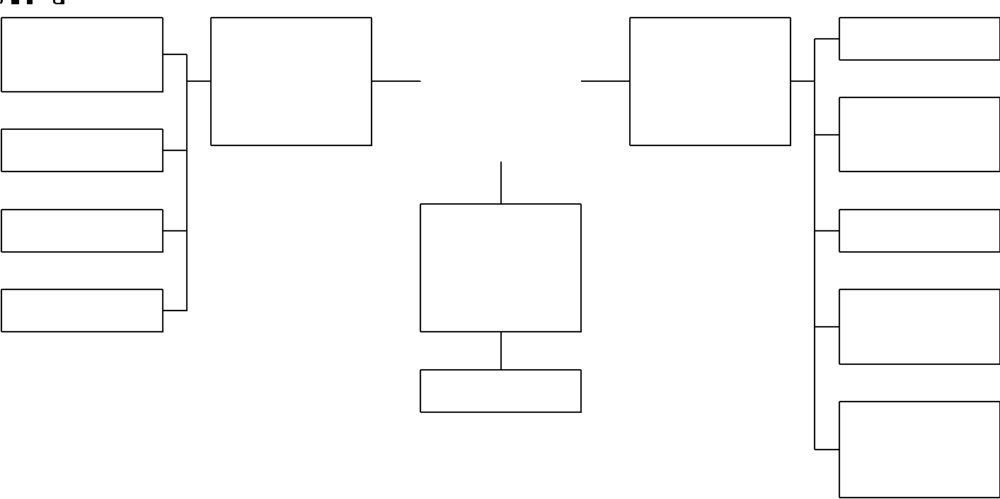

## Product Functions

Here’s primary product functions include:

* Web services and interfaces
* Data, data sources and analytics
* Geofencing
* Location- and interest-based alerts
* User-to-user messaging
* Event group messaging

## User Characteristics

Here is designed for a technically proficient user who is accustomed to using map-based and social/messaging smartphone applications. It is assumed users are familiar with basic mobile application navigation and are able to quickly adapt to using new features and functionalities.

Users should be fluent in English, located in the United States, and possess adequate dexterity to operate a smartphone. Users should also be active users of social media, including indication of interests.

## Constraints

Constraints include:

* Here only supports Android OS smartphones
* Android software is provided by and maintained by an external party (Google)
* Third party components are provided by and maintained by external parties
* Android devices are owned and maintained by external parties (e.g. users)
* Data is provided at the discretion of individual users
* User participation is at the discretion of individual users
* Device, connectivity, and application usage regulation is at the discretion of municipal and other regulatory bodies
* Civilian GPS accuracy is limited to approximately a 4.9 meter radius on a clear day

## Assumptions and Dependencies

Assumptions and dependencies include:

* Ability to connect with and source data from external provider APIs
* User device communication, location services, and cell / data connectivity availability
* Users with disabilities will be served by the underlying OS accommodations
* Users allow permission for application to access their location, contact list, and files
* Users allow permission for application to access their Facebook social media account
* Users actively use a Facebook account, including “friends” and “liked” pages

# External Interface Requirements

## User Interfaces

The user interface (UI) for Here shall launch with a default screen of a map, centered on the user’s current location as available. Events will be indicated visually. Notifications will appear as pop-ups. Users will select the menu option to access additional functionality modules: Events, Messaging, Profile, and Log Out.

## Hardware Interfaces

Here operates on Android-supported smartphone mobile devices. The Android OS will handle hardware interfaces once the user has approved access to the device’s file system, location, and contacts.

## Software Interfaces

Here operates on Android OS systems exclusively. It is optimized for Nougat (versions 7.0-7.1.2) but has reverse compatibility through Lollipop (versions 5.0-5.1.1).

## Communications Interfaces

Here will interface with the Facebook Graph API to obtain user data using JSON over HTTP. Here will interface with the Google Places API to obtain location information using Android’s gms common library**(?)**. The Firebase platform will support authentication and user communication using Google’s firebase.auth library**(?)**. HTTP will be used for the web service using Node JS Mongo DB driver as the interface between HTTP server and database.

# Domain Model

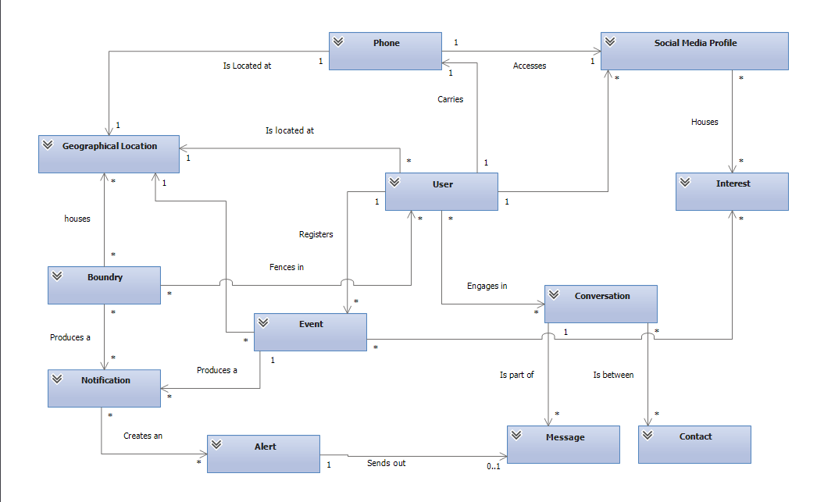

# System Features (Use Cases)

|  |  |
| --- | --- |
| **Number** | **1** |
| **Name** | **Log in and authentication** |
| **Scope** | Authentication |
| **Level** | User goal |
| **Primary Actor** | User |
| **Stakeholders and Interests** | User - access Here application functionality Here - provide users with a secure gateway to access application functionality Facebook/Firebase - provide users with a cross-platform option for authentication |
| **Preconditions** | User has a Facebook profile at the time of login |
| **Success Guarantee** | Valid authentication token is created and saved for the user |
| **Main Success Scenarios** | 1. User opens Here app 2. Here app checks for current user access token (if token is valid and active, go to step 7) 3. User selects Facebook login option (if user is already signed into Facebook, go to step 5) 4. User logs in to Facebook account 5. User approves access for Here via his / her Facebook account 6. Here creates and saves an authentication token per Facebook policy 7. Here app redirects user to app home screen |
| **Extensions** | If a user's authentication token is no longer valid or active or a user refuses to grant Facebook permission to Here, the user will be redirected to Here's login screen |
| **Special Requirements** | Error handling provided by Facebook/Firebase |
| **Technology and Data Variances** | Cell / data network availability |
| **Frequency of Occurrence** | Every time Here is opened |

|  |  |
| --- | --- |
| **Number** | **2** |
| **Name** | **Load Facebook interests** |
| **Scope** | Authentication |
| **Level** | User goal |
| **Primary Actor** | User |
| **Stakeholders and Interests** | User - share social media interests in order to match with relevant events Here - build a list of users' interests in order to match users with relevant events Facebook/Firebase - provide users with a cross-platform option for user data |
| **Preconditions** | User has a Facebook profile, has "liked" Facebook pages |
| **Success Guarantee** | All user Facebook page likes are loaded into Here as user interests |
| **Main Success Scenarios** | 1. User opens Here app 2. User authenticates Here via Facebook if necessary (see Use Case 1) 3. System extracts the user's Facebook page "likes" 4. System enumerates the user's "likes" as interests |
| **Extensions** |  |
| **Special Requirements** | **A maximum of 200 Facebook interests per user will be loaded**  Error handling provided by Facebook/Firebase |
| **Technology and Data Variances** | Cell / data network availability |
| **Frequency of Occurrence** | Every time Here is opened |

|  |  |
| --- | --- |
| **Number** | **3** |
| **Name** | **Create an event** |
| **Scope** | Events |
| **Level** | User goal |
| **Primary Actor** | User |
| **Stakeholders and Interests** | User - share events for matching with an interested audience; find events relevant to personal interests Here - provide a service to connect users who are hosting events with users who are interested in attending events |
| **Preconditions** | User has authenticated in Here |
| **Success Guarantee** | New user-created event is available for other users to be matched with/browse |
| **Main Success Scenarios** | 1. User opens Here and navigates to events screen 2. User selects the option to create a new event 3. System creates new event 4. User inputs event information: name, description, location, start date / time, end date / time, and associated interests 5. System saves event data as it is entered 6. Optional: user navigates away from the event |
| **Extensions** | Here will fire an error alert and ask the user to correct his/her input if: 1. User presses back button without entering complete, valid event data 2. User attempts to enter a start or end date or time in the past 3. User attempts to enter an end date / time that occurs before the start date/time |
| **Special Requirements** | Any user can create an event There is no uniqueness constraint on any event fields Past events will no longer be displayed or matched Event data is saved dynamically (no "save" option) |
| **Technology and Data Variances** | Cell / data network availability Keyboard / special characters |
| **Frequency of Occurrence** | Occasional - when a user wants to enter an event |

|  |  |
| --- | --- |
| **Number** | **4** |
| **Name** | **Modify an event** |
| **Scope** | Events |
| **Level** | User goal |
| **Primary Actor** | User |
| **Stakeholders and Interests** | User - update event so current information is used in event matching; find events relevant to personal interests with current information Here team - provide a service to connect users who are hosting events with users who are interested in attending events based on current information |
| **Preconditions** | User has authenticated in Here; user has created an event that needs to be modified |
| **Success Guarantee** | Modified user-created event is available for other users to be matched with/browse based on updated information |
| **Main Success Scenarios** | 1. User opens Here and navigates to events screen 2. User selects the event he / she wishes to modify 3. User edits the event information that needs modification 4. System saves event data as it is entered 5. Optional: user selects option to cancel event and confirms choice 6. Optional: system deletes event from app |
| **Extensions** | See Use Case 3 Users are able to view events other user created, but will only be able to edit the events they have created |
| **Special Requirements** | See Use Case 3 |
| **Technology and Data Variances** | Cell / data network availability Keyboard / special characters |
| **Frequency of Occurrence** | Occasional - when a user wants to enter an event |

|  |  |
| --- | --- |
| **Number** | **5** |
| **Name** | **Find user location** |
| **Scope** | Location |
| **Level** | User goal |
| **Primary Actor** | User |
| **Stakeholders and Interests** | User - view nearby events based on current location Here - track user location in order to match users with nearby events Google Places API - provide information and visual mapping for location data |
| **Preconditions** | User has authenticated in Here; user approved and enabled location services |
| **Success Guarantee** | Approximate user location is accurately captured within system |
| **Main Success Scenarios** | 1. User opens Here app and views home screen (map) 2. System obtains user location from available services 3. User location is displayed on home screen (map) and sent to background services 4. Periodically, system re-requests location as a background service 5. System obtains user location from available services 6. User location is displayed on home screen (map) (when viewing home screen) and sent to background services |
| **Extensions** | If a user's current location can't be found, the last known location will be displayed and used in background services |
| **Special Requirements** | Location refresh handling provided by Google Places |
| **Technology and Data Variances** | Cell / data network availability GPS availability |
| **Frequency of Occurrence** | Every time Here is authenticated, opened, and on a repeating interval when open |

|  |  |
| --- | --- |
| **Number** | **6** |
| **Name** | **Set up geofence** |
| **Scope** | Location |
| **Level** | User goal |
| **Primary Actor** | User |
| **Stakeholders and Interests** | User - identify the radius from current location for event matching Here - match users with events that are within a desirable distance Google Places API - provide information and visual mapping for location data |
| **Preconditions** | User has authenticated in Here; user approved and enabled location services; user location is captured |
| **Success Guarantee** | User's desired geofence is captured by Here and used in event matching; system confirms entry |
| **Main Success Scenarios** | 1. User opens Here app and displays user's current location on a map 2. User views profile screen 3. User enters desired proximity radius 4. System captures user's desired geofence and delivers a notification |
| **Extensions** |  |
| **Special Requirements** | The default proximity radius is 15 miles Location data will not be saved when Here is not in use - if no location is available, geofencing event notification service will not trigger Here will poll for new events when the application is (re-)opened |
| **Technology and Data Variances** | Cell / data network availability GPS availability |
| **Frequency of Occurrence** | Occasional - when a user wants to adjust geofence radius and/or reopens the Here app |

|  |  |
| --- | --- |
| **Number** | **7** |
| **Name** | **Get interest-based event notifications** |
| **Scope** | Notifications |
| **Level** | User goal |
| **Primary Actor** | User |
| **Stakeholders and Interests** | User - deliver / receive notifications for events that match interests, location, and current time Here - provide a service to connect users who are hosting events with users who are interested in attending events Google Places API - provide information and visual mapping for location data |
| **Preconditions** | User has authenticated in Here; user location is captured; user interests are loaded; event matches are available |
| **Success Guarantee** | User receives notification of events located within current location geofence, with current time parameters, and with matches to user interests; user does not receive notification of non-matching events |
| **Main Success Scenarios** | 1. User opens Here 2. System obtains user location (see Use Case 5) 3. System scans available events for location within user's current location geofence; with associated interests that match a user's interests; and with a start date up to 2 hours after current time and an end date that is in the future 4. System delivers an event notification to the user 5. User reviews the event notification |
| **Extensions** | Users may refer back to events they have been matched with via their events screen If no event time, location, and interest matches are available, the system will not deliver a notification Notifications will be shown regardless of application state |
| **Special Requirements** |  |
| **Technology and Data Variances** | Cell / data network availability GPS availability |
| **Frequency of Occurrence** | Occasional - based on user's location, interests, and time as well as available event options |

|  |  |
| --- | --- |
| **Number** | **8** |
| **Name** | **Browse events** |
| **Scope** | Events |
| **Level** | User goal |
| **Primary Actor** | User |
| **Stakeholders and Interests** | User - review events of interest and created events Here team - allow users to manage and refer back to their events |
| **Preconditions** | User has authenticated in Here; user has created an event and / or has selected option to confirm interest in event via event matching notification |
| **Success Guarantee** | All user-created and interested events are displayed |
| **Main Success Scenarios** | 1. User opens Here and navigates to events screen, which shows all events by default 2. Optional: user selects the filter label, causing only matched events to be shown 3. Optional: user re-selects the filter label, causing only the user's own created events to be shown 4. Optional: use re-selects the filter label, causing all events to be shown (continue to select the filter label to cycle through filter options) 4. User selects an event 5. User reviews event details 7. Optional: user selects the option to join the event conversation 8. User uses back button to return to events screen |
| **Extensions** |  |
| **Special Requirements** |  |
| **Technology and Data Variances** | Cell / data network availability |
| **Frequency of Occurrence** | Occasional - when a user wants to review events in a list |

|  |  |
| --- | --- |
| **Number** | **9** |
| **Name** | **View user profile** |
| **Scope** | Profile |
| **Level** | User goal |
| **Primary Actor** | User |
| **Stakeholders and Interests** | User - modify application-use settings  Here - customize app functionality based on user preferences Facebook/Firebase - provide users with a cross-platform option for authentication |
| **Preconditions** | User has authenticated in Here; user has a Facebook profile, has "liked" Facebook pages, and has Facebook "friends" |
| **Success Guarantee** | User setting changes are captured and applied |
| **Main Success Scenarios** | 1. User opens Here and navigates to profile screen 2. User reviews user name, email, and avatar as imported from Facebook under defaulted element 3. User selects element to review interest list as imported from Facebook 4. User selects an element to review contact list as imported from Facebook 5. User selects an element to review geofencing proximity radius setting 6. Optional: user adjusts geofencing proximity setting |
| **Extensions** |  |
| **Special Requirements** | Facebook-imported user name, email, avatar, and interests are read-only |
| **Technology and Data Variances** | Cell / data network availability GPS availability Keyboard / special characters |
| **Frequency of Occurrence** | Occasional - when a user wants to view or update profile settings |

|  |  |
| --- | --- |
| **Number** | **10** |
| **Name** | **Sync contacts with Here** |
| **Scope** | Authentication |
| **Level** | User goal |
| **Primary Actor** | User |
| **Stakeholders and Interests** | User - share contacts with Here to build a list of users he / she can communicate with on the app Here - provide a for users to communicate and connect Facebook/Firebase - provide users with a cross-platform option for connection |
| **Preconditions** | User has a Facebook profile, has Facebook "friends" |
| **Success Guarantee** | All user contacts are loaded into Here as contacts if they are also Here users |
| **Main Success Scenarios** | 1. User opens Here app 2. User authenticates Here via Facebook (see Use Case 1) 3. System extracts the user's Facebook friends 4. System enumerates the user's contacts who also use Here 5. Optional: user navigates to messaging screen to review contact list |
| **Extensions** |  |
| **Special Requirements** | Error handling provided by Facebook/Firebase |
| **Technology and Data Variances** | Cell / data network availability |
| **Frequency of Occurrence** | Every time Here is opened |

|  |  |
| --- | --- |
| **Number** | **11** |
| **Name** | **Message a friend** |
| **Scope** | Messaging |
| **Level** | User goal |
| **Primary Actor** | User |
| **Stakeholders and Interests** | User - send messages to other users in individual conversations Here - provide a way for users to privately communicate Firebase - provide a platform for user-to-user messaging |
| **Preconditions** | User has authenticated in Here; user has contacts in Here |
| **Success Guarantee** | Messages sent by user are delivered to intended recipient |
| **Main Success Scenarios** | **1. User opens Here and navigates to My Conversations screen OR User opens Here and navigates to the My Friends section of the My Profile screen** 2. User selects desired message recipient from contact list  3. User begins typing a message between the user and the recipient 4. User selects send  5. Message is delivered to the recipient and also shows on the user’s device |
| **Extensions** |  |
| **Special Requirements** | Error handling provided by Firebase |
| **Technology and Data Variances** | Cell / data network availability Keyboard / special characters |
| **Frequency of Occurrence** | Occasional - when a user wants to send a message |

|  |  |
| --- | --- |
| **Number** | **12** |
| **Name** | **Group messaging based on common event** |
| **Scope** | Messaging |
| **Level** | User goal |
| **Primary Actor** | User |
| **Stakeholders and Interests** | User - message among other users who are interested in the same event Here - provide a way for users to publicly communicate Firebase - provide a platform for user-to-user messaging |
| **Preconditions** | User has authenticated in Here; user has events in their events list with at least one other interested user |
| **Success Guarantee** | Messages are sent and delivered amongst at least two users with a common event |
| **Main Success Scenarios** | 1. User opens Here and navigates to event screen 2. User selects the option to "Join the Conversation" from the event details page 3. Optional: user sends or receives messages (see Use Case 11) |
| **Extensions** | User may also access group messaging via the messaging screen (if he / she has already participated in the conversation) Users can't participate in conversations for events they have not created or matched with |
| **Special Requirements** | **~~Notifications are only shown within the Here app when running~~** |
| **Technology and Data Variances** | Cell / data network availability Keyboard / special characters |
| **Frequency of Occurrence** | Occasional - when a user wants to send or receives a message |

|  |  |
| --- | --- |
| **Number** | **14** |
| **Name** | **Browse home screen** |
| **Scope** | Events |
| **Level** | User goal |
| **Primary Actor** | User |
| **Stakeholders and Interests** | User - review events of interest and created events  Here team - allow users to manage and refer back to their events  Google Places API - provide information and visual mapping for location data |
| **Preconditions** | User has authenticated in Here; user has events in their events list |
| **Success Guarantee** | User is able to move about the screen and view event details |
| **Main Success Scenarios** | 1. User opens Here and stays on the home screen  2. Optional: user uses gestures to move around map, zoom in/out, or find their location (see Use Case 5)  3. Optional: user selects filter button to show only matched events  4. Optional: user re-selects filter button to show all events  5. Optional: user selects event marker label to view event details |
| **Extensions** |  |
| **Special Requirements** |  |
| **Technology and Data Variances** | Cell / data network availability |
| **Frequency of Occurrence** | Occasional - when a user wants to reviews events on a map |

# Other Nonfunctional Requirements

## Performance Requirements

* Here shall respond to 90% of requests in less than 5 second from the time the request is received by the system

## Safety Requirements

* Here shall restrict membership per Facebook community guidelines

## Security Requirements

* Here user profiles require authentication for access
* Here does not display user location data to other users
* Here applies filters to user input in order to remove malicious code injection attempts

## Software Quality Attributes

* Here shall be able to support at least 100 simultaneous active users
* Here shall maintain availability of at least 98% not including scheduled downtime
* Here shall maintain reliability of at least 1 hour mean time between failures

# Other Requirements

* Managing and Processing Application Data:
  + The system shall store event data on the application server
  + The system shall store user data on the application server
  + The system shall store authentication data with the authentication service platform (Firebase)
  + The system shall store messaging data with the messaging service platform (Firebase)
  + The system shall not store user location data
  + The system shall store all other application data on the user’s device
* Managing and Processing User Location Data:
  + Identify user’s location within 5 seconds of GPS satellite access.

*When a user opens the application and allow use of location services on phone the application will register their location in less than 5 seconds to their account.*

* + Calculate proximity of two or more users and/or location within 2 meter accuracy.

*The system will accurately keep distance data between users and other users or locations to an accuracy of less than 2 meters under an open sky. (per GPS.gov civilian GPS accuracy can be up to average 4.9 meters).*

* + Handle location data of 1,000 users within one square kilometer.

*The system will be able to store and process 1,000 users who are actively using application with location services turned on.*

* + If user is in the same WiFi network, no need to poll for GPS again
    - Location data will be stored in double precision Decimal Degrees.

*Any GPS coordinates received by the application that is in Degrees Minute Seconds (DMS) will be converted to Decimal Degrees (dd) and stored with an 8 byte precision floating precision.*

* + The system will assign distance alert limits as the following:
    - Minimum Incoming boundary entry alert limit is 2 meters.
    - Minimum outgoing boundary exiting alert limit for geo fenced area will be 5 % of the geo fenced area in meters. With outgoing boundary defined as anything leaving a geo fenced area. Users will be alerted.
    - Maximum Incoming boundary will be 1 mile.
  + System will be able to accept in / out “alert” boundary crossing data as following:
    - If system data analyzer detects a point crossing a radius limit will be used.
* User to User Location Based Message Data Processing:
  + System will send location based message to its destination when boundary settings defined in 7.1.6 in less than 3 seconds latency.
  + Messages shall be handled over a secure encrypted protocol/connection.
  + Received messages and locations from a user should be stored into the database within less than a second from being received.
  + System shall be able to process 1,000 messages per minute from different users.
* Interest Data and Broadcasting Processing:
  + Data analytics shall retrieve data from other social media platforms as well as application profile and process the data and users profile in less than a second.
  + The system shall rank interest of users if two or more users are within a certain predefined distance from an event/location. A list is returned of users from most comparable interest to least for all users.
* User to User Profile Data Processing:
  + Data analytics shall be able to run and update user locations and profile data every 5 seconds while application is open and receiving updates.
  + System shall be able to handle up to 1000 users interacting with a geo fenced area in order to receive notifications.
  + System shall continue to update user data and interests while logged in even if GPS location is temporarily lost for up to 10 minutes.